MODELS

1. SUPERVISED MODEL I – Logistic Regression
VERSION 1
- training dataset used: training_features_with_labels
- test dataset used: test_features
- parameters
  - C = 1.0 (regularization strength)
- submission.npz: logistic_regression.npz
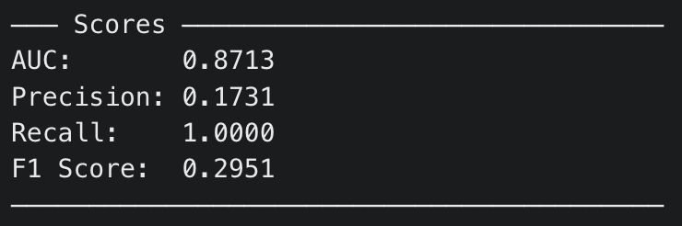

2. SUPERVISED MODEL II – 1. MLP, 2. MLP-SMOTE
VERSION 1
- training dataset used: training_features_with_labels
- test dataset used: test_features
- model architecture:
  - two hidden layers: 64 neurons, then 32 neurons
- parameters:
  - val_split = 0.15
  - initial_learning_rate = 0.001
  - activation = “relu”
  - max_iter = 500
  - early_stopping = True
- submission.npz (MLP): mlp.npz
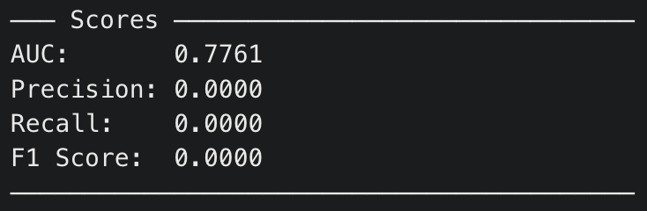
- submission.npz (MLP-SMOTE): mlp_smote.npz
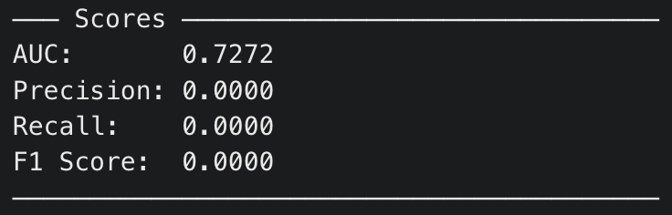

Feature Engineering

VERSION 1
features:

from scipy.stats import entropy as sp_entropy

def engineer_features(interactions_df):
"""
Takes a dataframe with columns [user, item, rating]
Returns a dataframe with one row per user and all engineered features.
"""
df = interactions_df.copy()

# === Basic Statistics ===
user_df = df.groupby("user")["rating"].agg(
rating_mean="mean",
rating_std="std",
rating_median="median",
rating_min="min",
rating_max="max",
rating_count="count"
)
user_df["rating_std"] = user_df["rating_std"].fillna(0)
user_df["rating_range"] = user_df["rating_max"] - user_df["rating_min"]

# === Rating Entropy ===
# first calculate the rating distribution for each user
rating_dist = df.groupby(["user", "rating"]).size().unstack(fill_value=0)
rating_dist = rating_dist.reindex(columns=range(6), fill_value=0)
rating_props = rating_dist.div(rating_dist.sum(axis=1), axis=0)
# Then use the distribution/proportion for each rating, to calculate entropy
user_df["rating_entropy"] = rating_props.apply(
lambda row: sp_entropy(row[row > 0]), axis=1
)

# === Item Popularity ===
item_popularity = df.groupby("item")["user"].count().rename("item_popularity")
df_with_pop = df.merge(item_popularity, left_on="item", right_index=True)
pop_features = df_with_pop.groupby("user")["item_popularity"].agg(
avg_item_popularity="mean",
std_item_popularity="std"
)
pop_features["std_item_popularity"] = pop_features["std_item_popularity"].fillna(0)
user_df = user_df.merge(pop_features, left_index=True, right_index=True, how="left")

# === Deviation from Consensus ===
item_avg = df.groupby("item")["rating"].mean().rename("item_avg_rating")
df_with_item_avg = df.merge(item_avg, left_on="item", right_index=True)
df_with_item_avg["deviation"] = df_with_item_avg["rating"] - df_with_item_avg["item_avg_rating"]
dev_features = df_with_item_avg.groupby("user")["deviation"].agg(
mean_deviation="mean",
std_deviation="std",
abs_mean_deviation=lambda x: np.mean(np.abs(x))
)
dev_features["std_deviation"] = dev_features["std_deviation"].fillna(0)
user_df = user_df.merge(dev_features, left_index=True, right_index=True, how="left")

user_df = user_df.reset_index()

return user_df

